**FocussedModePlus Install Guide**

To install FocussedModePlus on your Windows System – kindly follow the below mentioned steps…..

1. Right click on the setup file – and select ‘Run as Administrator’ from the Context Menu (as shown below)

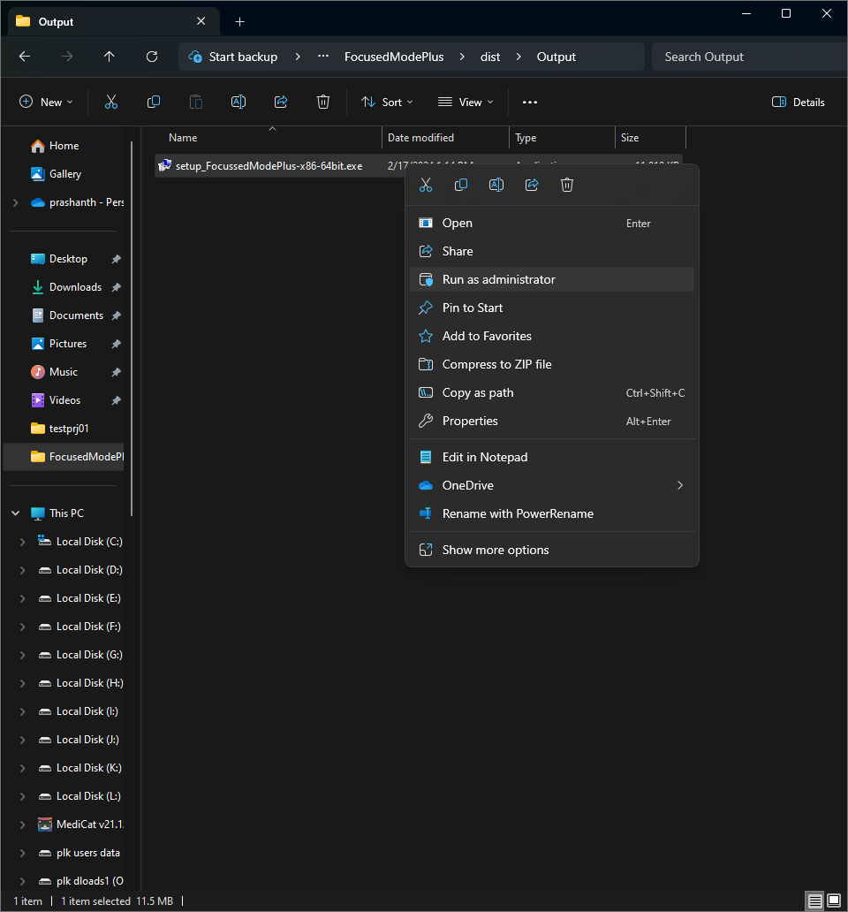

1. You may get a Security Warning (as shown below). Click on Yes to proceed further

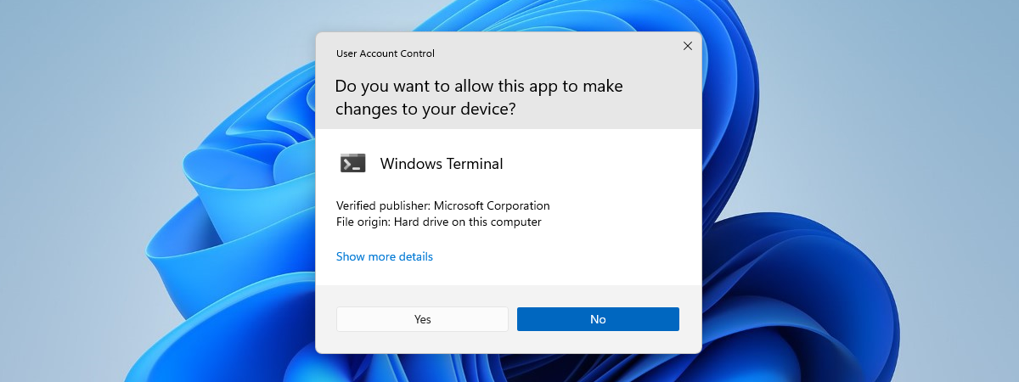

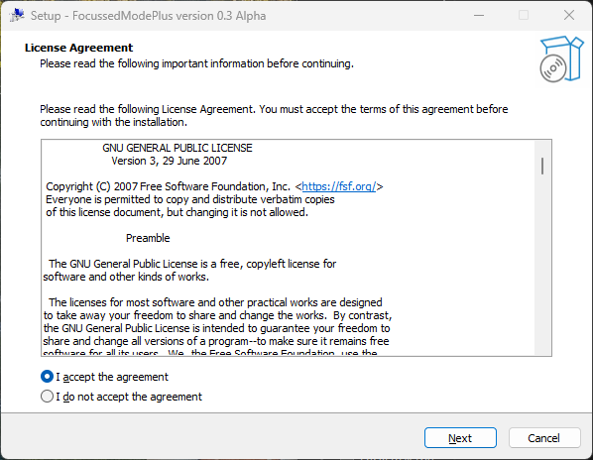

1. The Installation Wizard Starts (as shown Above). Agree to the License Agreement and Click Next

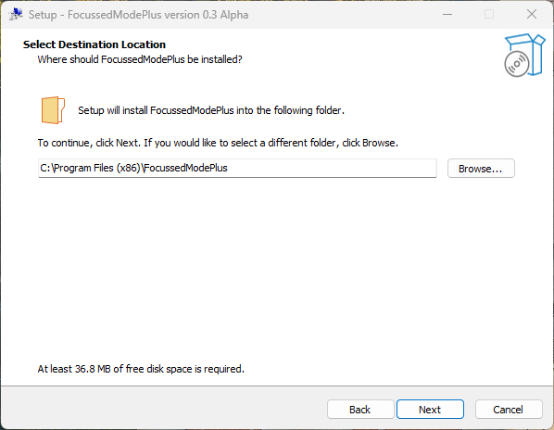

1. Select the Directory where you want to install FocussedModePlus – and click Next to proceed

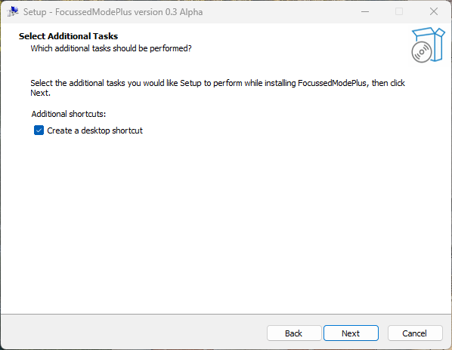

1. If you want a Shortcut for FocussedModePlus on your Desktop – Select the Checkbox. Then click Next to proceed further

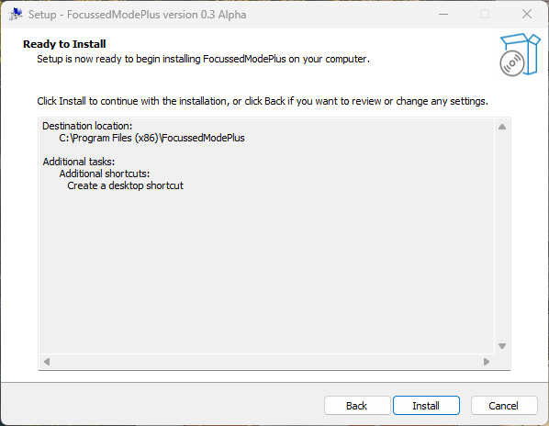

1. Now you’ll see a Summary of the Install process. Click on Install to proceed with the Actual Installation of FocussedModePlus

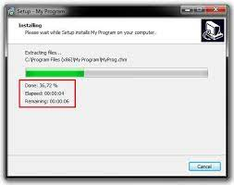

1. You’ll see a Progressbar during the Installation

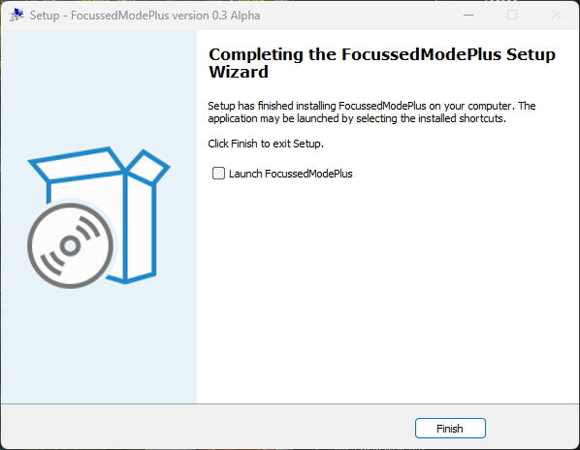

1. Now click on Finish to end the Installation

With that, FocussedModePlus should be installed and ready to use on your System.

**Uninstall….**

To Uninstall FocussedModePlus – Follow these steps……

1. Locate FocussedModePlus in the Start menu – and click on Uninstall
2. You may get a Security Warning (as shown below). Click on Yes to proceed further
3. Click Uninstall. You may get a Confirmation dialog. Click Yes to begin the Uninstall process.
4. FocussedModePlus is now Removed from your system…..